



**PROJECT REPORT**

**Plant Palace**

Theme: eGreenNursery

Category: Website Design and Development

**Table of Contents**

1. **Introduction**
   1. Background and Necessity for the Website
2. **Project Overview**
   1. Scope of Project
   2. Constraints
3. **Requirements Analysis**
   1. Functional Requirements
   2. Non-Functional Requirements
4. **Interface Specifications**
   1. Hardware
   2. Software
5. **Design and development**
   1. Architecture of web application
   2. Data Flow Diagram (DFD)
   3. Source Code
6. **User Guide**
   1. System Requirement
7. **Realizing Success: Project Deliverables**
   1. Delivering Excellence: The Fruits of Our Endeavors
8. **Introduction:**

**1.1 Background and Necessity for the Website**

The necessity for a plant nursery website arises from the surge in gardening interest, demand for plants, and online shopping convenience. This stems from factors like the growing fascination with gardening for relaxation and aesthetics. A website is crucial due to the diverse range of plant species nurseries offer, each with unique traits and care needs. Such a platform lets nurseries showcase their collection and helps customers make informed choices.

The website provides accessibility and convenience by allowing customers to browse and purchase plants online, transcending geographical boundaries and store hours. It acts as an information hub, offering details about each plant species, fostering responsible gardening practices, and matching plants to customers' environments. The site's search and filtering features aid users in efficiently finding plants aligned with their preferences, saving time and enhancing the overall experience.

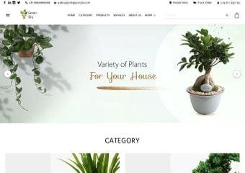Furthermore, the website facilitates customer engagement and loyalty through features like wish lists, personalized recommendations, and informative blogs. This strengthens the connection between nurseries and customers, encouraging repeat purchases and referrals. In essence, the digital platform serves as an educational, transactional, and interactive haven for both avid gardeners and those discovering the joy of nurturing plants.

1. **Project Overview**

'PlantPalace' emerges as an integrated digital hub, merging e-commerce and botanical exploration seamlessly. Designed for plant enthusiasts, the platform offers an all-encompassing online experience. By uniting shopping and plant-related knowledge, 'PlantPalace' simplifies the process of exploring and acquiring diverse plant species. Users can expect organized selections, powerful search tools, and detailed insights into each plant's origin and care.

This document serves as a comprehensive guide to 'PlantPalace,' highlighting its multifunctional essence. The platform empowers users to embark on an immersive botanical journey, facilitating plant purchases and providing botanical insights. This concise document outlines the project's objectives, functionalities, user interface, and operational scope. Catering to stakeholders and developers alike, it ensures a shared understanding of 'Plant Palace’s' aspirations and implementation.

**2.1 Scope of Project**

This Web portal will be a responsive and visually appealing Website to be used by individuals.

**2.2 Constraints**

The web portal will notably lack a storage capability on its server. Instead, data retrieval will be achieved through JSON/TXT files, presenting users with visible content. Nevertheless, the portal will abstain from enabling information alteration within these files directly from its interface.

1. **Requirement Analysis:**

**3.1 Functional Requirements**

* **Pages and menus**
* Catalog Display
* Search and Navigation
* Sorting and Filtering
* Plant Information
* Shopping Cart and Checkout
* Feedback
* Contact Us
* Sitemap

**3.2 Non Functional Requirements**

* Website Security
* User Accessibility
* Intuitive User Experience
* Operational Reliability
* Optimal Performance
* Scalability
* Continuous Availability
* Cross-Browser Compatibility

1. **Interface Specification**
   1. **Hardware**

Intel Core i5 Processor or higher, 8 GB RAM or higher, Color SVGA, 500 GB Hard Disk space, Mouse, Keyboard

**4.2 Software**

HTML5, CSS3, Bootstrap (optional), JavaScript, Figma Toolkit, jQuery, AngularJS/Angular 9/ReactJS, XML; JSON/TXT

1. **Design and Development**

* 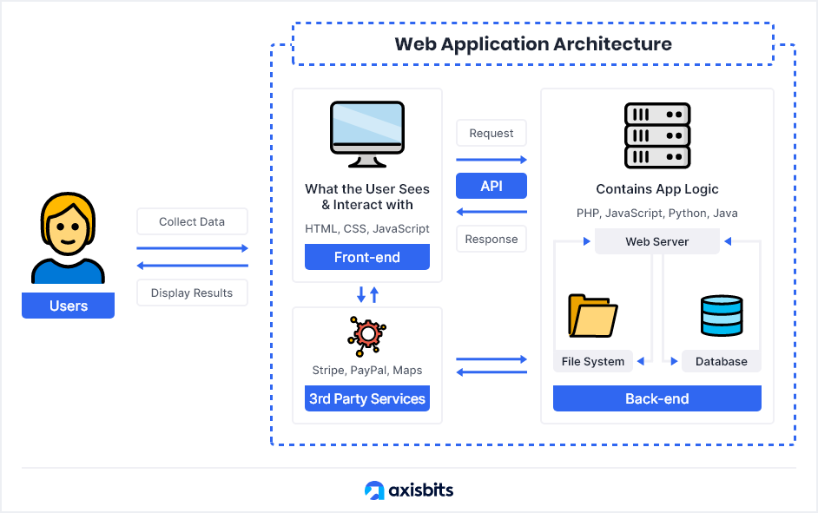**Architecture of web application**
* **Data Flow Diagram (DFD)**

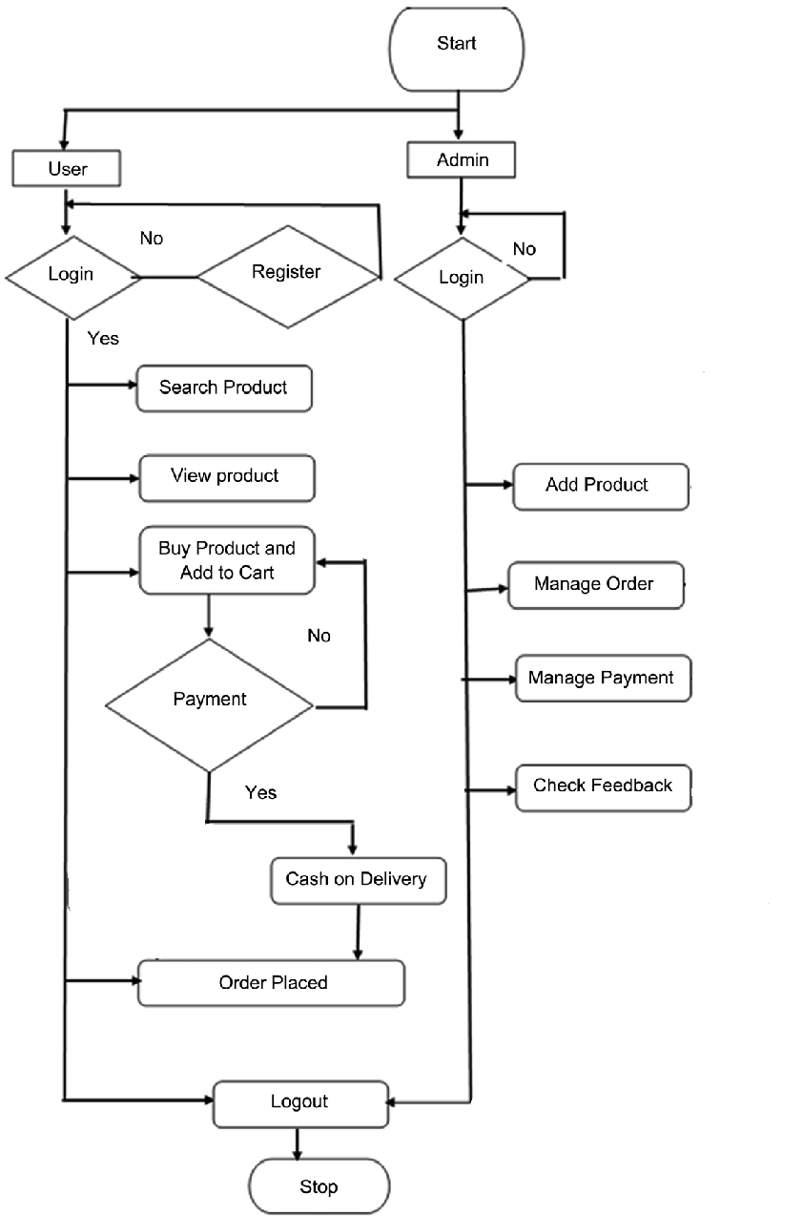

* **Source Code**

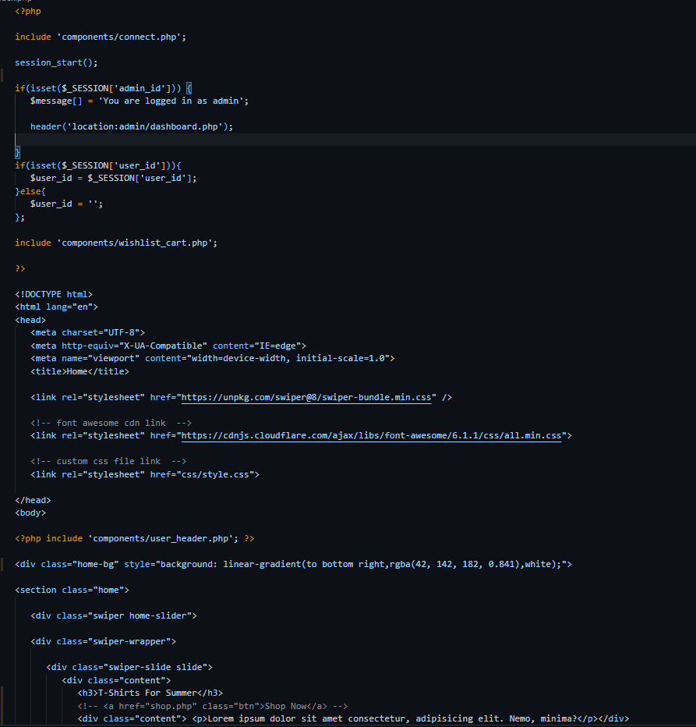

1. **User Guide:**
   1. **System requirement**

|  |  |  |
| --- | --- | --- |
| s.no | Items | description |
| 1. | Operating system | Microsoft windows 8.1, 8, 10 or higher |
| 2. | Software | Visual studio code 2017 or higher |
|  |  |  |

1. **Realizing Success: Project Deliverables**

[add some front end pictures here]